**ZMM130**

*Project report of minor project submitted in fulfilment of the requirement for the degree of*

**BACHELOR OF TECHNOLOGY**

**IN**

**INFORMATION TECHNOLOGY**

By

**Rahul (15192610037)**

**Vijaya Kumari (15192610061)**

**UNDER THE GUIDANCE OF**

**Mr. Gaurav Sood**



**UNIVERSITY INSTITUTE OF TECHNOLOGY, HIMACHAL PARDESH**

**UNIVERSITY, SHIMLA**

**March,2023**

**DECLARATION**

We hereby declare that the work reported in the B.Tech. Project Report entitled **“ZMM130”** submitted at the **University Institute of Technology, Himachal Pradesh University, Shimla** is an authentic record of our work carried out under the supervision of **Mr. Gaurav Sood.** We have not submitted this work elsewhere for any other degree or diploma.

Rahul Vijaya Kumari Sahil Sharma

15192610037 15192610060 15192610042

This is to certify that the above statement made by the candidates is correct to the best of my knowledge.

Mr. Gaurav Sood

Date:

Head of the Department/Project Coordinator

**ACKNOWLEDGEMENT**

I thank the almighty for giving us the courage and perseverance in completing the minor project. This project itself is an acknowledgement for all those people who have given us their heartfelt co-operation in making this project a grand success. With extreme jubilance and deepest gratitude, I would like to thank our mentor, Mr. Gaurav Sood, for his constant encouragement. I am profoundly grateful for the unmatched services rendered by all my team members. Our special thanks to all the faculty of the Information Technology Department and peers for their valuable advice at every stage of this work. Finally, we would like to express our deep sense of gratitude and earnest thanksgiving to our dear parents for their moral support and heartfelt cooperation in doing the minor project.

**LIST OF FIGURES**

**SAP (System application and products in Data Processing)**

**SAP** stands for Systems Applications and Products in Data Processing. SAP, by definition, is also the name of the ERP (Enterprise Resource Planning) software as well as the name of the company. SAP Software is a European multinational, founded in 1972 by Wellen Reuther, Hopp, Hector, Plattner, and Tachira. They develop software solutions for managing business operations and customer relationships.

The SAP system consists of several fully integrated modules, which cover virtually every aspect of business management. [SAP](https://www.guru99.com/sap-training-hub.html) is #1 in the ERP market. As of 2010, SAP has more than 140,000 installations worldwide, over 25 industry-specific business solutions and more than 75,000 customers (about the seating capacity of the Los angles Memorial Coliseum) in 120 countries. Other Competitive products of SAP Software in the market are Oracle, Microsoft Dynamics, etc.

In SAP there are so many modules under it one of them is **SAP ABAP.**

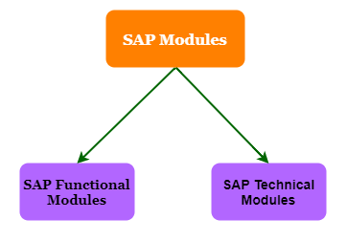

**SAP ABAP**

**SAP:** -Systems, Applications and Products in data Processing

**ABAP-** Advanced Business Application Programming

ABAP is a fourth-generation programming language, used for development and customization purposes in the SAP software. Currently positioned along with Java, as the main language for SAP application server programming, most of the programs are executed under the control of the run-time system.

SAP ABAP is a high-level language that is primarily used to develop enterprise applications for large business and financial institution on SAP platform.

An important feature to point out is that ABAP is feature driven. This means that the execution of an app will be affected by system events and user actions.

All ABAP programs run within the ABAP Runtime environment. This is a part of the SAP kernel. The runtime environment is used for processing statements in ABAP. It is also used in handling events and the flow logic of screens.

Let us see how the runtime works. First, the ABAP code is stored in the SAP database. Here, the code exists in 2 forms – source code and generated code. You can edit the source code via the ABAP workbench. The generated code is the source code represented in binary. Thus, the source and generated code of a program are stored in the database.

When your program is executed from the front end, the program buffer is checked to see whether it exists or not. If the program is not found, then a call to the database is made from the runtime environment to fetch it. All the statement processing and user events are handled by the runtime. The database interface converts ABAP statements (Open SQL) into native SQL statements.

**Requirement**: - Requirement from the business. The need of the report is to execute based on MRP type and record and get all the requirement of the material.

Previously they used -MB5B but the issue with that is they can't run it on multiple material so to overcome that thing now currently they are using zmm130.

MB5B

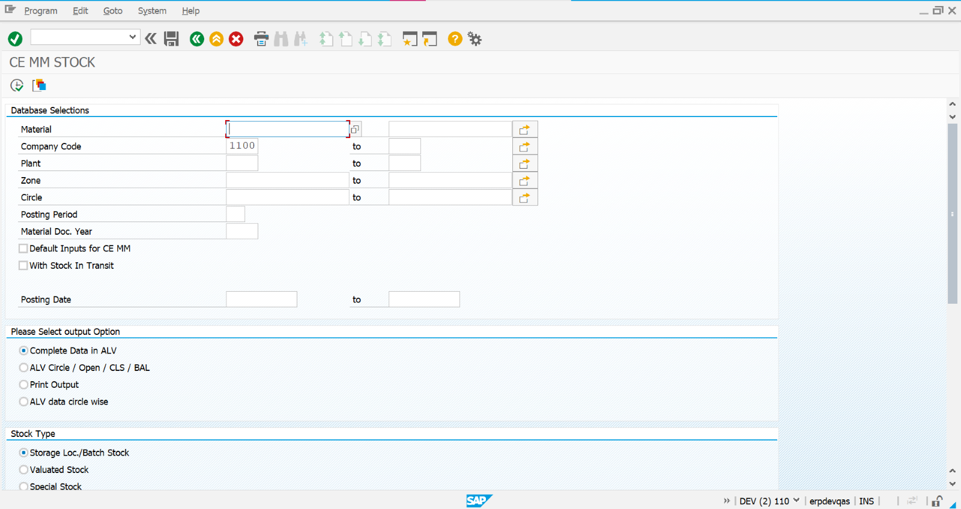

ZMM130



**ZMM130**

ZMM130 is a T- Code used to access the material report in sap.

ZMM is a full display interface of purchase of goods in material management.

The report contains different displays options of material purchase.

**ALV**

The ABAP List Viewer (ALV) is a set of application programming interfaces (APIs; function modules or classes) for displaying data in a tabular or hierarchical format and built-in options for visual presentation and event processing.

ALV is originally short for [ABAP](https://learning.sap-press.com/abap) List Viewer, but the current term found in SAP documentation is *SAP List Viewer*. This is of little importance, though: in everyday practice, it’s simply referred to as ALV, not by any longer name.

To users, ALV offers a friendly interface with a toolbar that allows each user to adjust the presented layout to their preferences and sort or filter data easily. Many standard SAP reports use ALV, and it has become a popular tool when building custom ABAP reports due to its flexibility, ease of implementation, and variety of features.

## **ABAP List**

The first tool for data output in tabular format was *ABAP List* (see figure below). Such output was generated by using the WRITE command to display one line of data on the screen. To present the data in a grid format, the fields needed to be placed at specific, static positions on the screen while processing data in a loop or a cycle.

This type of presentation, traditional in mainframe-based systems for the last century, was inconvenient for both developers and users. Developers had to write all the code manually to output each field, as well as the column headers and totals or subtotals. And users were offered only a rigid report structure that they couldn’t modify without requesting a change in the program. Making changes in such reports was also inconvenient and time-consuming.

**--There are 4 different option to display the output**

1.Complete data in ALV: -AVL (ABAP LIST VIEWER)

In this no information list data is absent complete data is show without any filter or abstraction

Almost whole information single big volume unit.

It includes complete information of selected types like plant, zone, circle anything.

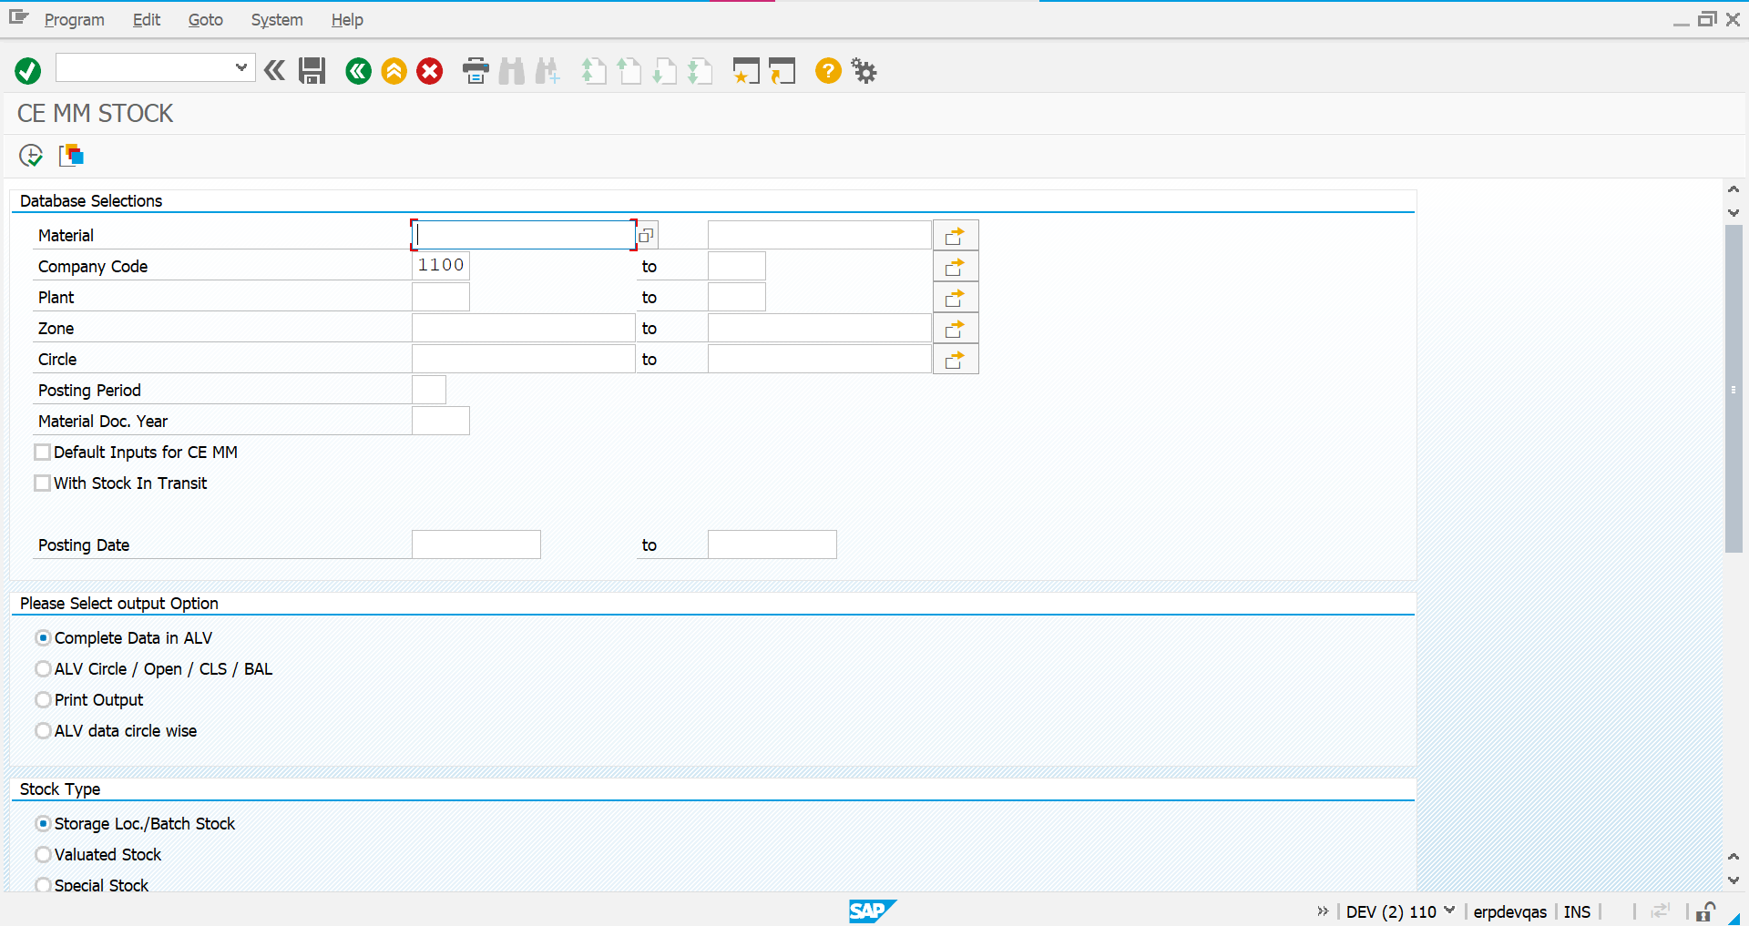

**2.ALV Circle/open/Cls/Bal: -**

This display output used when one need an output specific circle data display

Open and Cls is an open and close display in report data output

Bal is balance sheet data in alv

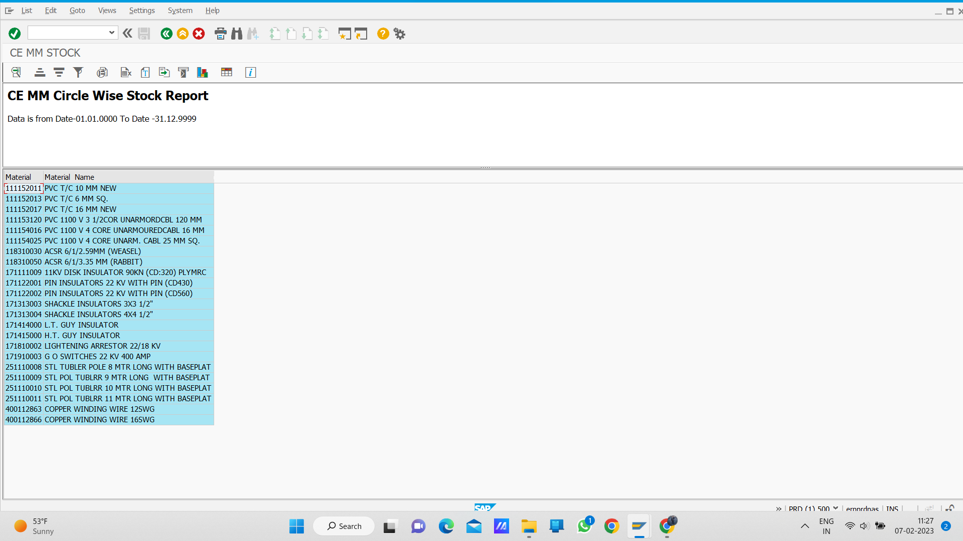

**3.Print output: -**

This option gives the output of the selected unit type.

Print preview can be seen or have preview screen.

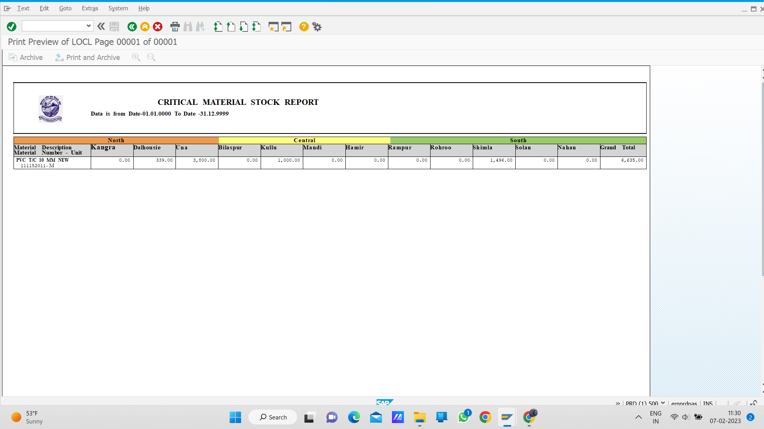

4.Alv data circle wise: -

Gives List view of data report on screen circle wise.

Selected circle information display on the screen.

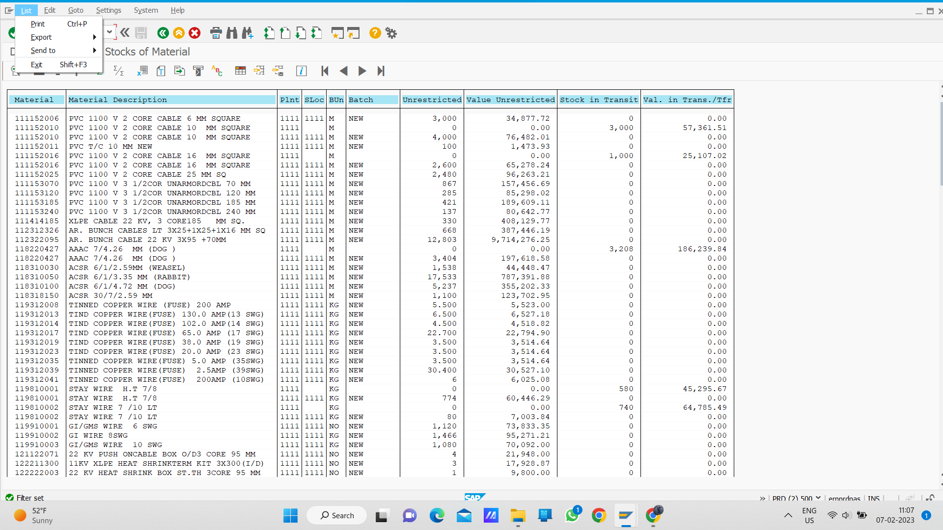

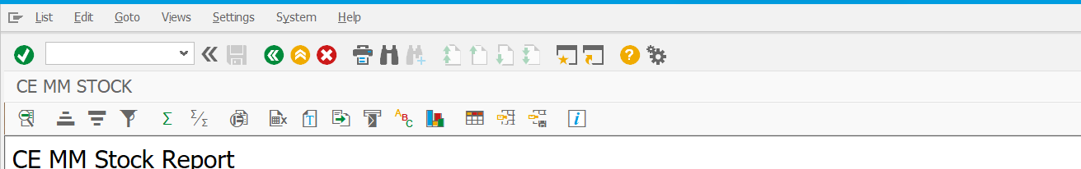

**DIFFERENT OPTIONS:** -

**Ascending Order:** - It shows data in ascending order I.e., it shows data from higher to lower digit.

**Descending order: -** it shows data in descending order I.e., it shows data from lowest to higher value.

**Filter: -** one of the important options for having the exact information about what the user desires to find.

**Change layout: -**change layout of the display output.

**ABC Analysis: -** analysis of the output data.

**Conclusion: -**

After working on zmm130, which is a report on material management, we find that it is easy to have a view of transaction data of material purchase or other transaction.

Finding data for a particular term or section becomes easy.

**References: -**

* SAP Community [Tour the SAP Community](https://developers.sap.com/tutorials/community-2023.html) and explore the various features of SAP Community.
* Sams Teach Yourself ABAP/4® in 21 Days.
* <https://help.sap.com/docs/SAP_PROFITABILITY_AND_COST_MANAGEMENT/2a1e337ac18d4557af55f1789f48aecb/fae59fb26faf1014878bae8cb0e91070.html>
* <https://help.sap.com/docs/SAP_S4HANA_ON-PREMISE/2c0f74c2ca4d401d92b7d727798d6c94/7b47d153da7e4308e10000000a174cb4.html>

## **ALV List**

The first implementation of the ALV framework was the *Classic SAP List Viewer*, usually referred to as *ALV List*. As you can see in the next figure below, this was a major improvement over the plain ABAP List functionality: the columns are nicely aligned and the toolbar offers additional functionality, such as sorting, filtering, and subtotals. More importantly, users could choose which columns they wanted to view and in which order. Their preferences could be saved in a *layout* to be applied next time they run the report.

For developers, ALV offered a unified set of tools for data presentation, with no more calculating the screen position of each column and writing all the code manually. When using the ALV framework, developers only needed to be concerned with preparing business data; the ALV framework took care of the presentation.

Classic SAP List Viewer supported single-level lists, like the one shown below, and multilevel or sequential lists.



**- ZMM130 window contain different options to display the data explained below: -**

**Material: -** material contains all the materials details specified with unique code digit.

**Company code: -** digit code given to the company**.**eg;1100

**Plant: -** Plant is a unit site or place which transactions of material are done.

**Zone: -** There is three zone define in zmm130 north south center according to the area side.

**Circle: -**circle are sub divided area of zone

**Posting period:** -period of data updated entries in report data.

**Material doc. Year: -**document write details of material according to time year

**--There are 4 different option to display the output--**

1.Complete data in ALV: -AVL (ABAP LIST VIEWER)

1. In this no information list data is absent complete data is show without any filter or abstraction
2. Almost whole information single big volume unit.
3. It includes complete information of selected types like plant, zone, circle anything.

ehU,{eae73636-9487-4de9-9f70-b6492b48eeb7}{236},3.125,3.125

**2.ALV Circle/open/Cls/Bal: -**

* This display output used when one need an output specific circle data display
* Open and Cls is an open and close display in report data output
* Bal is balance sheet data in alv

U,{9dc45883-a143-4a11-ab2f-4c26302aea30}{64},3.125,3.125

**3.Print output: -**

* This option gives the output of the selected unit type.
* Print preview can be seen or have preview screen.

U,{9dc45883-a143-4a11-ab2f-4c26302aea30}{126},3.125,3.125

4.Alv data circle wise: -

* Gives List view of data report on screen circle wise.
* Selected circle information display on the screen.
* U,{9dc45883-a143-4a11-ab2f-4c26302aea30}{196},3.125,3.125

U,{9dc45883-a143-4a11-ab2f-4c26302aea30}{210},13,2.8125

DIFFERENT OPTIONS: -

**Ascending Order:** - It shows data in ascending order I.e., it shows data from higher to lower digit.

**Descending order: -** it shows data in descending order I.e., it shows data from lowest to higher value.

**Filter: -** one of the important options for having the exact information about what the user desires to find.

**Change layout: -**change layout of the display output.

**ABC Analysis: -** analysis of the output data.

Conclusion: -After working on zmm130, which is a report on material management, we find that it is easy to have a view of transaction data of material purchase or other transaction.

Finding data for a particular term or section becomes easy.

References: -

* SAP Community [Tour the SAP Community](https://developers.sap.com/tutorials/community-2023.html) and explore the various features of SAP Community.
* Sams Teach Yourself ABAP/4® in 21 Days.
* <https://help.sap.com/docs/SAP_PROFITABILITY_AND_COST_MANAGEMENT/2a1e337ac18d4557af55f1789f48aecb/fae59fb26faf1014878bae8cb0e91070.html>
* <https://help.sap.com/docs/SAP_S4HANA_ON-PREMISE/2c0f74c2ca4d401d92b7d727798d6c94/7b47d153da7e4308e10000000a174cb4.html>